**Kocaeli University Electronics and Telecommunication Engineering**

**Digital Communications Laboratory**

**Experiment 6:** **BPSK Modulation and Demodulation – Simulink Lab Report**

In phase shift keying (PSK), the phase of a carrier is changed according to the modulating waveform which is a digital signal. In Binary Phase Shift Keying (BPSK), the transmitted signal is a sinusoid of fixed amplitude. It has one fixed phase when the data is at one level and when the data is at the other level, the phase is different by 180 degrees. A BPSK signal can be defined as

$s_{BPSK}(t)=A Cos\left(2πf_{c}t+\left\{\begin{matrix}0 if m\left(t\right)=1 \\ π if m\left(t\right)=0\end{matrix}\right.\right)$, where m(t) is the binary information.

In the lab experiment, Bernoulli Binary generator block generates 0 and 1 bits with equal probability. Unipolar to Bipolar converter is employed. *M* should be 2 in this block. Thus, the output of the adder module becomes a polar signal (+/-1). Then, the polar signal is multiplied by a carrier signal whose frequency is $f_{c}$ and BPSK modulated signal is obtained.

At the receiver part, the signal is multiplied with the carrier that is same carrier signal at the transmitter part. This demodulation is called Coherent Demodulation. Construct the below block diagram for baseband BPSK Modulation & Demodulation.

**Figure 1** Baseband BPSK Modulator and Demodulator Block Diagram

**Required Blocks**

1. Bernoulli Binary Generator
2. Sine Wave for carrier signal
3. Gain
4. Sum
5. Multiplier
6. Analog filter
7. Inequality
8. Scope
9. Error Rate Calculation
10. Display

**Table 1.** Parameters for Carrier Sine Wave

|  |  |
| --- | --- |
| Amplitude | 1 |
| Frequency | 2*pi*1000 |
| Phase | pi/2 |
| Sample Time | 1e-5 |

**Table 2.** Parameters for Analog Filter Block

|  |  |
| --- | --- |
| Design method | Butterworth |
| Filter type | Low pass |
| Filter order | 8 |
| Passband edge frequency | 2*pi*100 |

**Figure 2** Source property

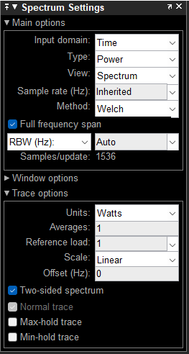

**Figure 3** Spectrum Settings

**Figure 4** Error Rate Calculation Config

1. Set the carrier frequency as $f_{c}=1000$ Hz. Run the code for 0.08 seconds. After obtaining BPSK signal, take a screenshot of the scope result of the message signal and explain what you see.
2. What is the bandwidth of the BPSK modulated signal according to first zero-crossing? Observe it using spectrum analyzer. Hint: Set the simulation stop time as 5 Sec, sample time of the zero-order holder as -1. Use the spectrum settings illustrated in Figure 3.
3. In Figure 1, the same local oscillator is used at the transmitter and the receiver. To investigate the phase effect, set the value of the constant block in Figure 5 equal to 0.25e-3 and 0.5e-3. Observe the LPF outputs and add their screenshots to your report. Observe BER values and fill them in the table below, explain the reason for errors (Simulation Stop time must be 5 Sec).

**Figure 5** Generating phase shift

|  |  |  |
| --- | --- | --- |
| **Time Delay** | **BER Value** | **Explain** |
| 0.25e-3 |  |  |
| 0.5e-3 |  |  |

1. Set the value of the constant block in Figure 5 equal to 0. Change Sample time of Bernoulli Binary Generator block **(source)** as (1/200). Observe its effect on scope and spectrum analyzer. Does the bandwidth of the modulated signal change? Explain why.
2. At the receiver low pass filter (LPF) is used for coherent demodulation. When sample time of **source** changes, should we change the cut-off frequency of LPF? Is there any relation between them?